  - College of Business  - student consulting Program  Fully supervised by experienced faculty, the Stony Brook University College of Business Student Consulting Program has assisted clients with their strategic business decisions for over 30 years.  Completed over a 15 week semester every fall and spring, teams of full time undergraduate and graduate students work on projects in Marketing, Finance, Operations and Accounting for clients spanning a variety of industries - technology, pharmaceuticals, municipalities, and consumer products, just to name a few.  Together we can create a project that will address your goals to achieve results. So, contact us today. There is no time like the present to begin planning for a more successful future.  Please see reverse side for a list of the companies students have worked with and the scope of the projects.  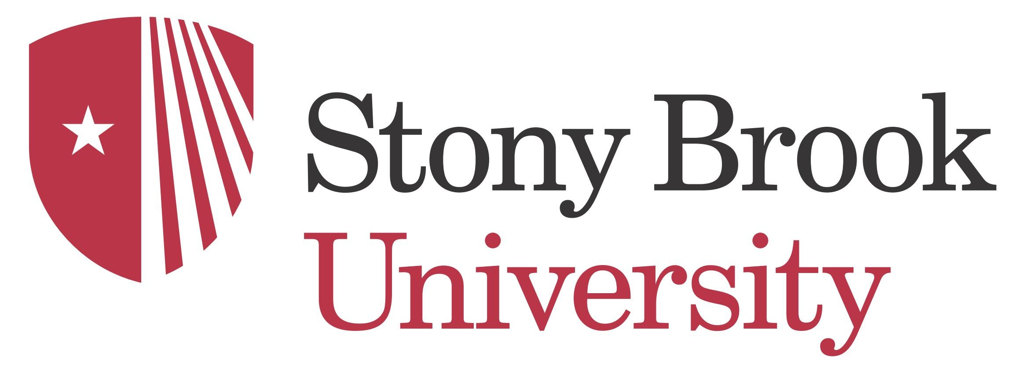  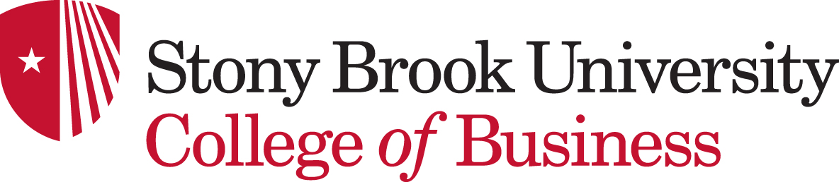  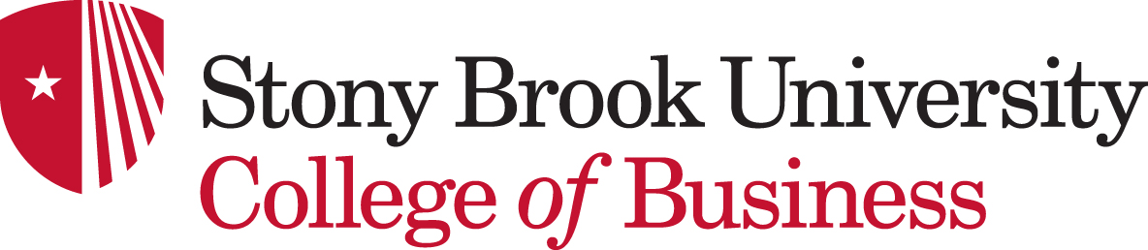 |  | Do you have a challenge facing your business?  Looking for some new ideas?  A College of Business Student Consulting Team may be your answer  Request your Project Application and Description  Camlle Abbruscato  Director  Marketing Projects and Business Relations  (631) 632-5733  camille.abbruscato@  stonybrook.edu  RAFAEL AGUAYO  Finance and Operations Projects  jose.aguayo@  stonybrook.edu  COLLEEN MCKEAN  Project Management Projects  colleen.mckean@  stonybrook.edu
Company Name | Scope of project
Anchel Technologies | New Product Marketing/Market Analysis
Aunt Diane Cookies | Branding/Marketing Communications
Hilton Garden Inn | Advertising
Ants and Things | Marketing
ClearVision Optical | Digital Marketing
Eduware | Marketing
Softheon | Marketing/Operations/Financial Analysis
Target Corporation | Marketing/Marketing Research
Brown’s FIAT | Advertising
Uncle Wally’s | Marketing Research
Sunrise Medical | Process Improvement
GEICO | Marketing/Marketing Research
Stony Brook University FSA | Marketing Research
Edirectory.li | Marketing Research
Thermolift | New Product Marketing/ Market Analysis
Town of Riverhead | Market Analysis/Financial Analysis
Konsyl Pharmaceuticals | Marketing Research/New product marketing
Spruce Enterprises | Financial Analysis
Imagination Playground | New Product Marketing/Marketing Research
Fastenal | Marketing/Marketing Research
The Lark Pub and Grill | Marketing/Marketing Research
Holiday Inn | Marketing
Island Federal Credit Union | Marketing/Marketing Research
Outdoor Survival | Digital Marketing/New Product Marketing
Oyster Bay Chamber of Commerce | Marketing
Bay Street Theater | Marketing/Social Media
Missing Piece | Web Design/Marketing
AMA | Event Marketing
NARI (National Association of Remodeling Industry) | Marketing Research/Membership Retention
Enterprise Holding | Marketing
AFTEE (All for the East End) | Web Design/Video Production
Apogee | Customer Service/Process Management

